Phase I and Phase II Results – Arizona (AZ)

A. Plots of Predictors vs. HPI (simple returns)

Original HPI Series
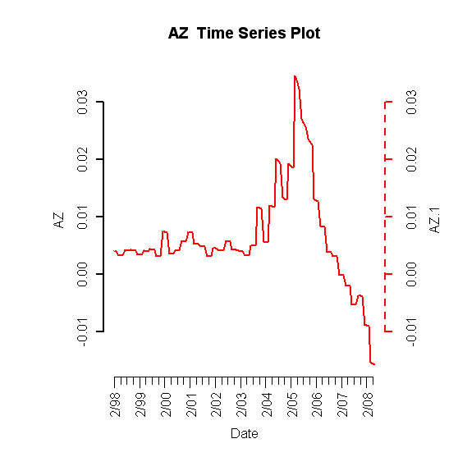

Building Permits
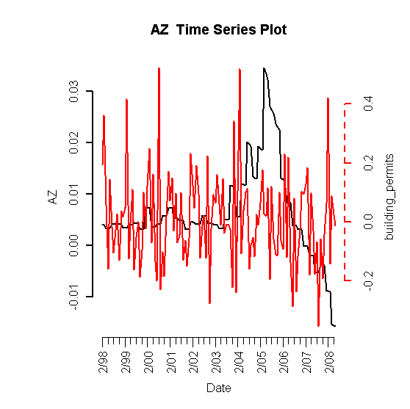

Foreclosures
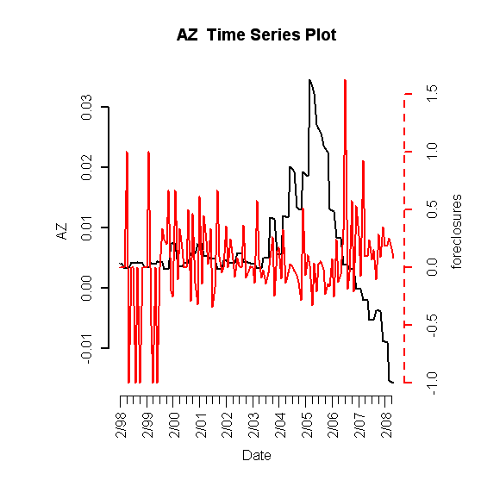

Population Size
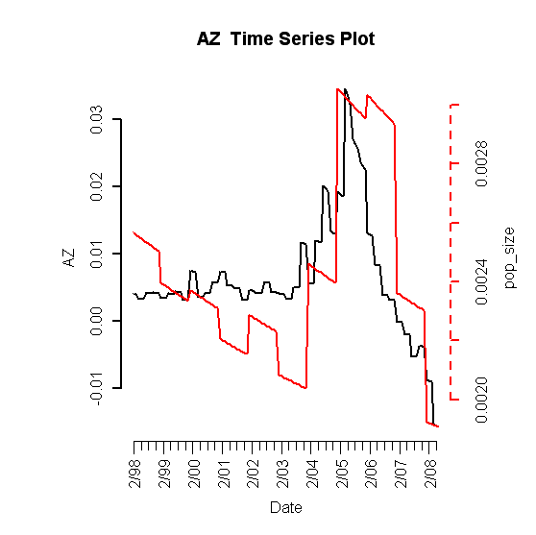

Unemployment Rate
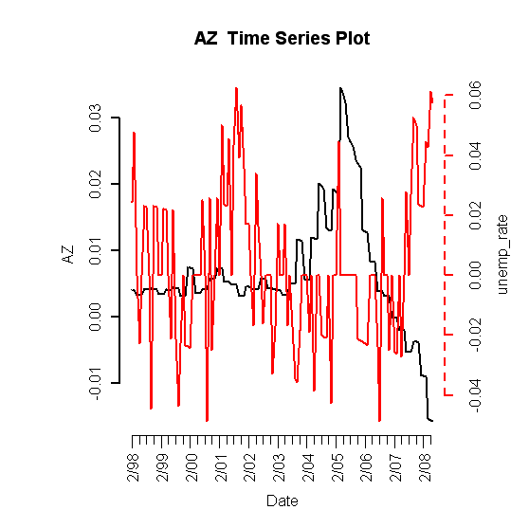
Mortgage Originations

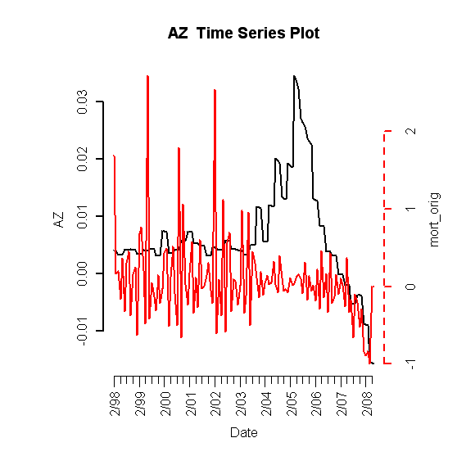
30-Year Commitment Rate
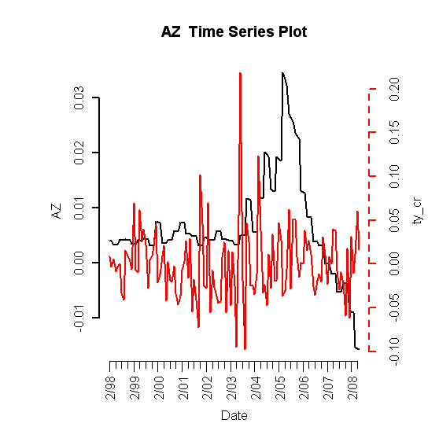

Median Income
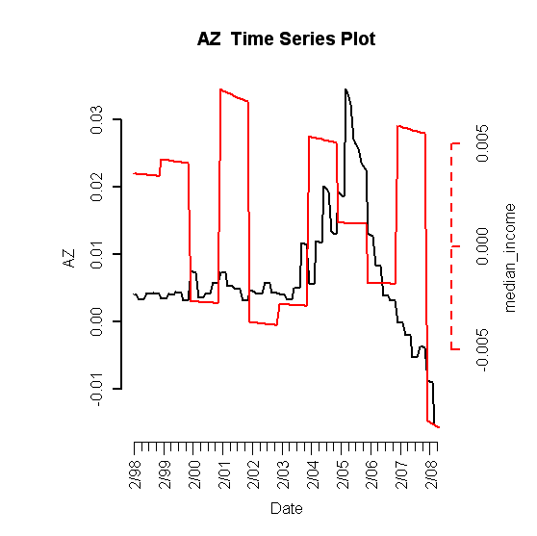
B. Plot of Lagged Predictors vs. HPI (simple returns)

Foreclosures (lagging 12 months)
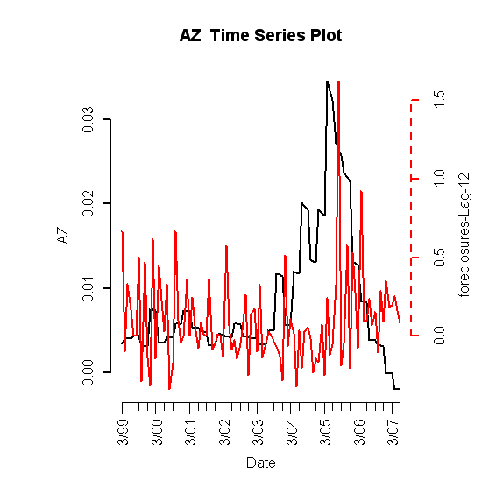

Unemployment Rate (leading 1 month)
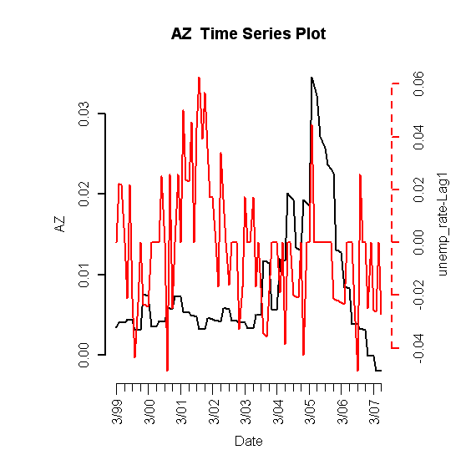

Population Size (lagging 6 months)
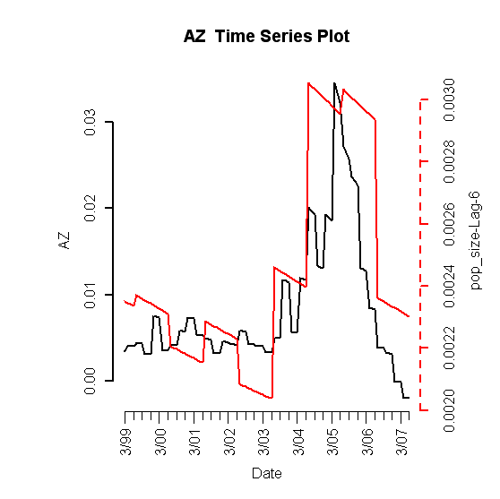

C. Scatterplots (simple return)

C. Final RLM Model

Robust Linear Model (significant predictors only)

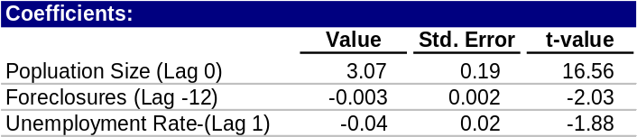

1. Phase I

ACF of Residuals
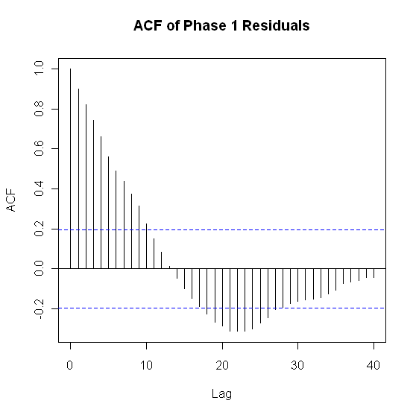

ACF of Sq-Residuals
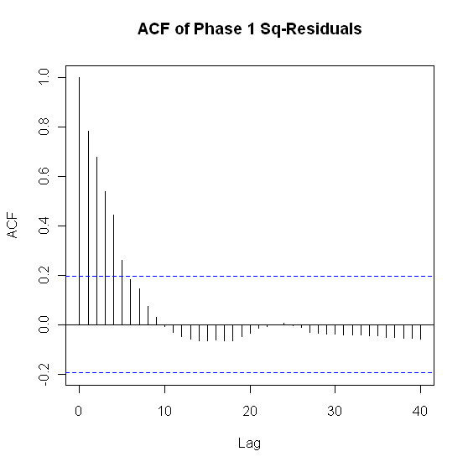

2. Phase II

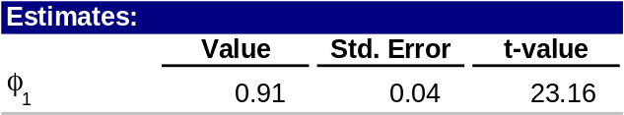

ACF of Residuals
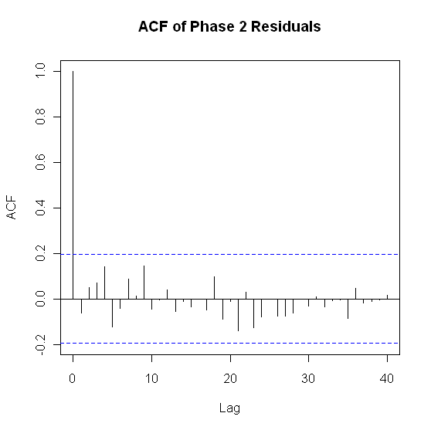

ACF of Sq-Residuals
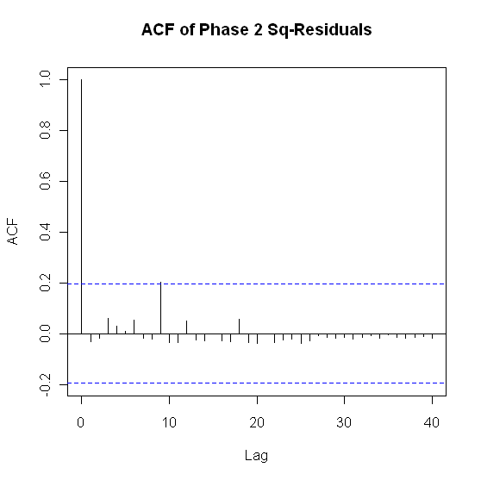
3. Model Checking Diagnostics

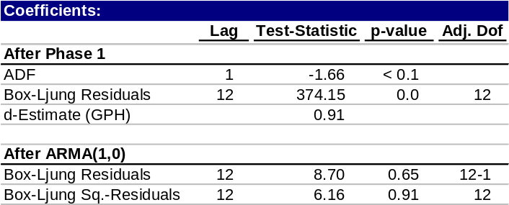

E. Fitted vs. Actual Plots

Fitted Phase 1 Fitted Values vs. HPI
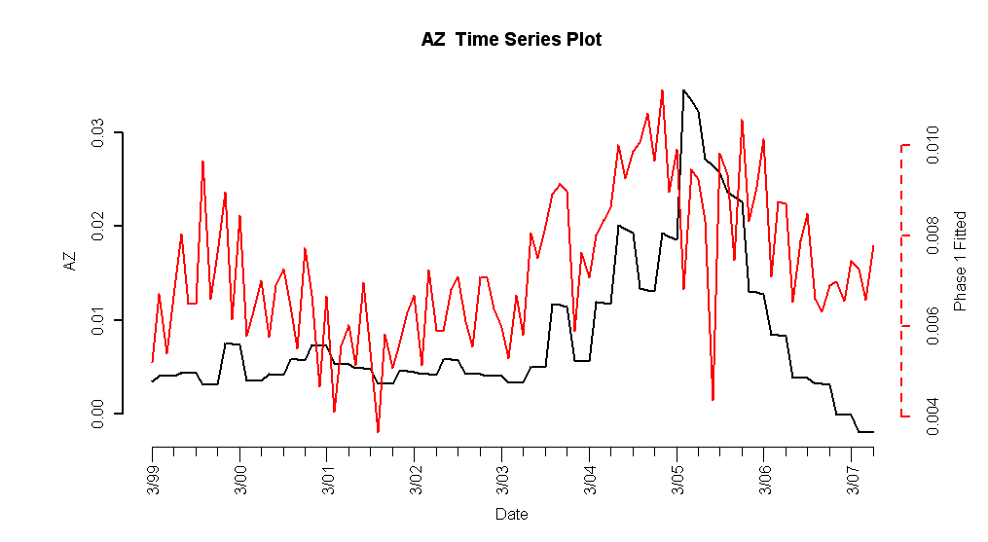

Phase1 Residuals vs. HPI
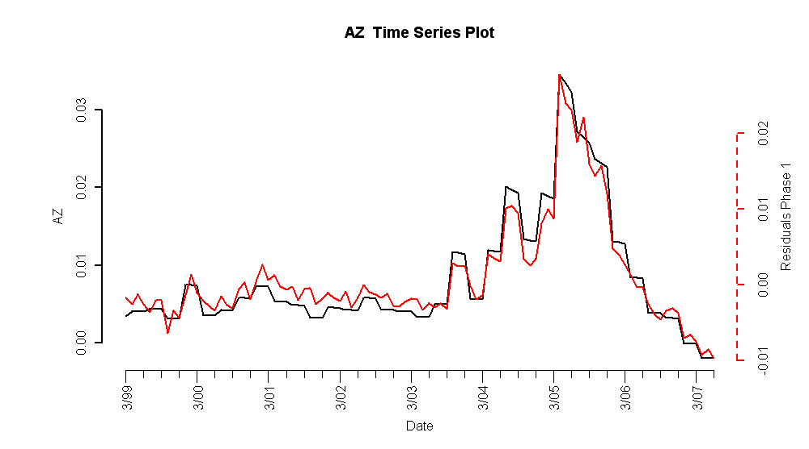

Fitted Phase 1/2 Values vs. HPI
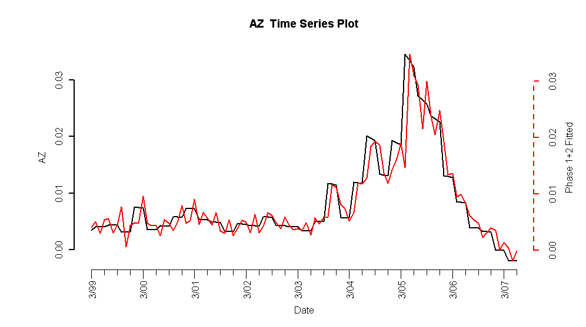

Phase 2 Residuals vs. HPI
